**Module 1:**

**Why use a guideline?**

____________________________________________________________________________________________________________________________________________________________________________________________________________________________________________________________________________________________________________

**Championing a Problem**

Identify a problem or practice change in your organization or community that you would like to champion.



**ACTIVITY 1: Recommendation and Discussion of Evidence  
Person- and Family-Centred Care Clinical Best Practice Guideline, 2015**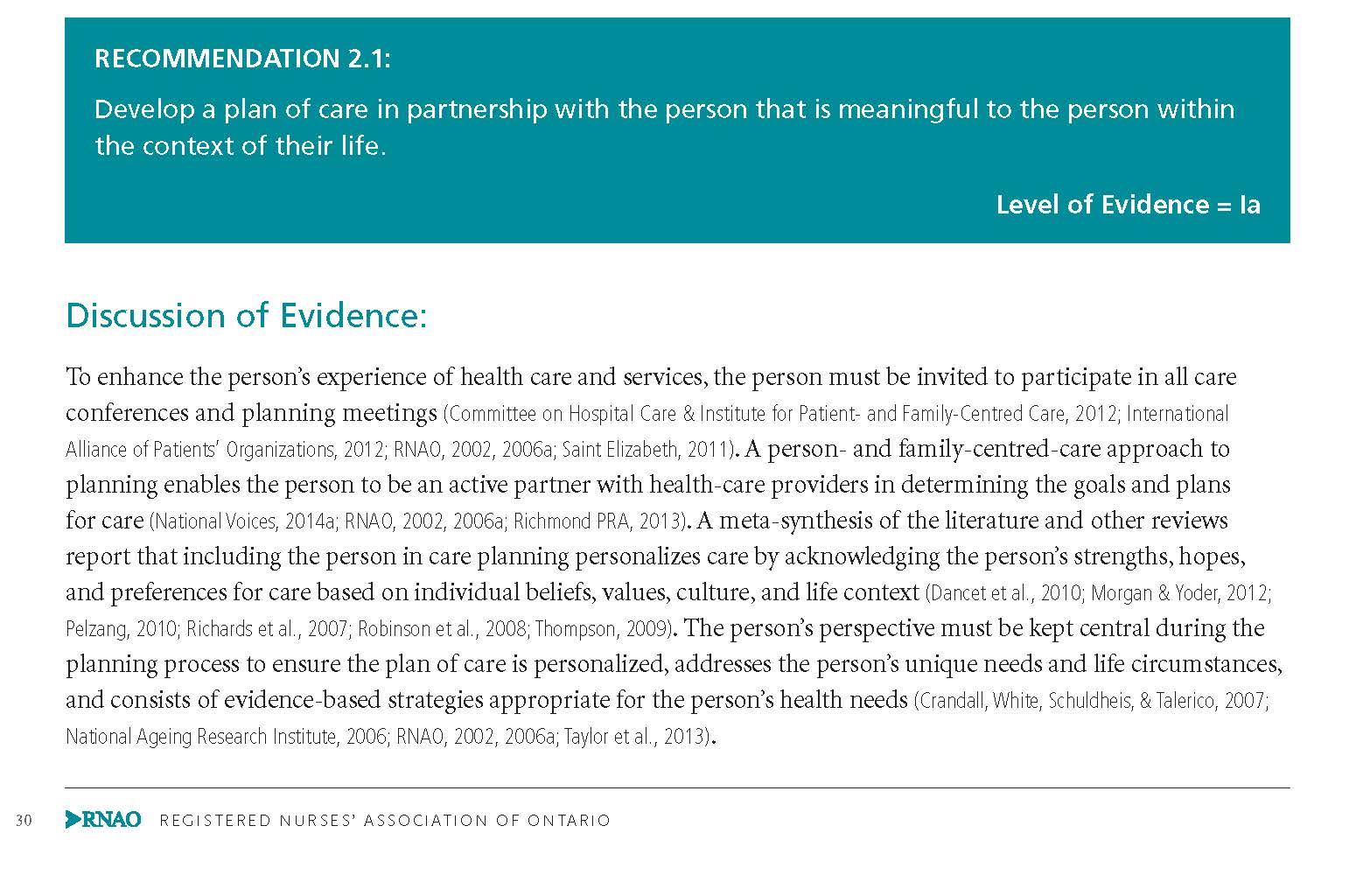

**In your groups, read the Recommendation and Discussion of Evidence (DOE) on the previous page and answer the following questions:**

1. What is the recommendation asking you to do? It may help to circle key words or phrases.

____________________________________________________________________________________________________________________________________________________________________________________________________________________________________________________________________________________________________________

1. According to the DOE, why is this recommendation important?

____________________________________________________________________________________________________________________________________________________________________________________________________________________________________________________________________________________________________________

3. How might you/your team implement this recommendation? ____________________________________________________________________________________________________________________________________________________________________________________________________________________________________________________________________________________________________________

**ACTIVITY 2: Gap Analysis**

Read each recommendation

Think about your workplace, and consider if these practices are met, unmet or partially met

Add comments to explain your answer

Consider which recommendations are priorities and how you might evaluate them

**Person- and Family-Centred Care Clinical Best Practice Guideline, 2015**

Date_____________ BPG Reviewer(s) _____________________________________________________

|  |  |  |  |  |
| --- | --- | --- | --- | --- |
| **Recommendation** | **Met** | **Unmet** | **Partially met** | **Comments** |
| PLANNING- Recommendation 2 .1 Develop a plan of care in partnership with the person that is meaningful to the person within the context of their life. |  |  |  |  |
| EVALUATION-Recommendation 4 .1:  Obtain feedback from the person to determine the person’s satisfaction with care and whether the care delivered was person- and family-centred. |  |  |  |  |

**ACTIVITY 3: Building a Common Vision with Stakeholders**

Draw a triangle

Draw a banana shape

Draw a circle

Draw 9 lines

Draw 5 M’s

**ACTIVITY 4: Indentifying Evaluation Indicators**

Review your Gap Analysis Tool and choose one priority. Develop a SMARTER evaluation goal for that priority and identify one or more possible indicators to measure success.

|  |  |  |
| --- | --- | --- |
| **Recommendation** | **Evaluation Goal** | **Indicator** |
|  |  |  |
|  |  |  |

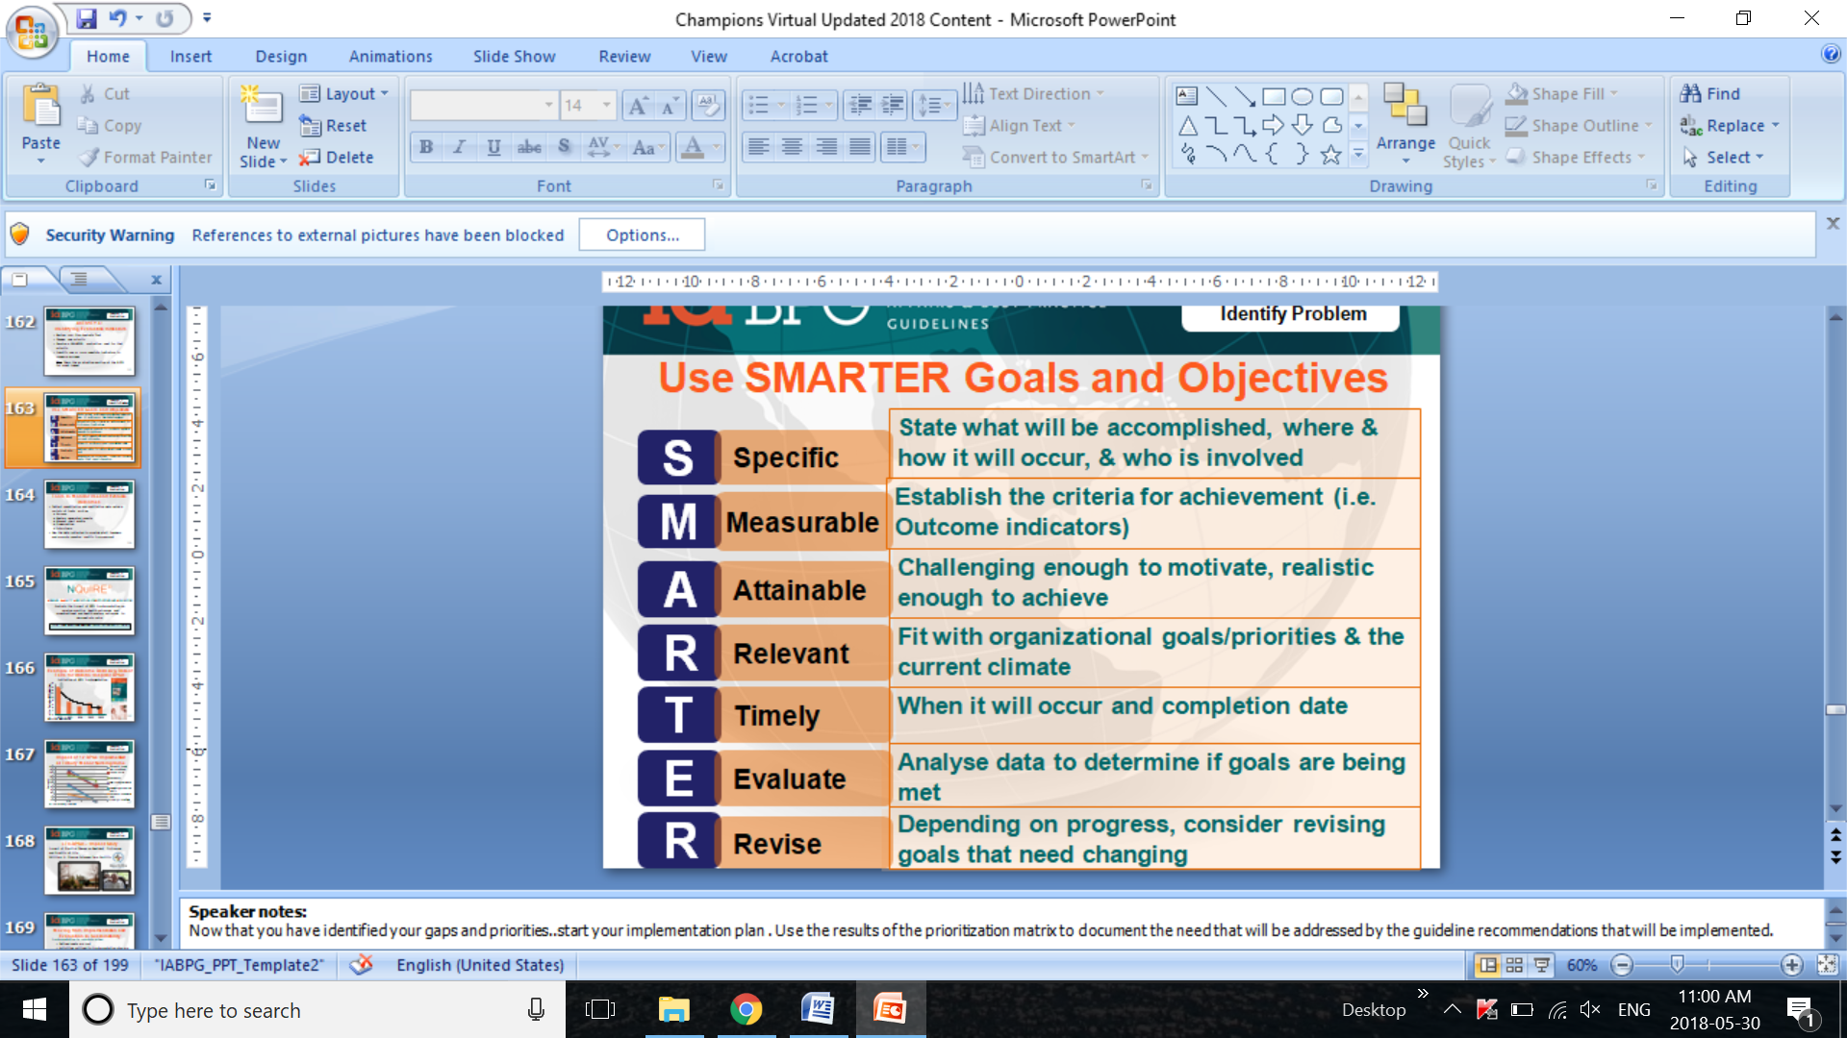

**ACTIVITY 5: Evaluation Elevator Pitch**

**In three sentences or less, discuss how you would tell your Manager/ Lead:**

* + - **This is what our project achieved...**
    - **Here is the impact of our nurse-led intervention on our clients/patients/ residents'.**
    - **This is what we need to spread/sustain**

__________________________________________________________________________________________________________________________________________________________________________________________________________________________________________________________________________________________

**Question: What does sustainability mean to you?**

__________________________________________________________________________________________________________________________________________________________________________________________________________________________________________________________________________________________

**NOTES**